Lady Beatle @ La Boite Theatre Review
- Written by Majella McMahon
- Tuesday, 30 May 2017 12:02
Published in Arts News

Image © Howard Duggan
Bringing back The Beatles is a daunting task for any performer, but Naomi Price and her 'Lonely Hearts Club Band’ did it in a way that felt both joyous and genuine.
‘Lady Beatle’ is a moving story told by a mysterious fan set to the soundtrack of The Beatles. The storyteller, aka the Lady Beatle (played by Price), seems to somehow be both inside the inner sanctum of The Beatles while simultaneously looking in from the outside... But as the story unfolds, we begin to understand whose tale is being told.
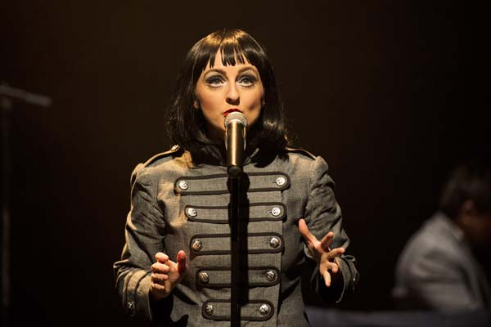
Image © Dylan Evans
Price is a charismatic performer, bringing to life an authentic accent and connecting emotionally, mentally and physically to her character. She lights up the stage and wears her heart on her sleeve which makes for mesmerising viewing. Add to this her soaring, sparkling vocals which brought the audience to their feet, united in their appreciation of a true talent.
Supporting her and bringing their own kind of sizzle to the show was her backing band ‘The Lonely Hearts Club Band’ with musicians Michael Manikus, Mik Easterman, Jason McGregor and Andrew Johnson. Each brought an individual flair to their musical part and looked like they were thoroughly enjoying themselves.
The cabaret stage set up was simple yet effective with one feature lighting display hanging directly above Price which changed to match the mood of the song or dialogue. The costumes were designed by Leigh Buchanan and embraced a blend of simplicity and sexiness and were integral in unifying the story through style. The narrative was imagined by the creative dream team of Price and Adam Brunes who together run The Little Red Company, a magical place that has created past musical masterpieces including ‘Wrecking Ball’ and ‘Rumour Has It’.
The show was filled with fizz and pop, ribald riffing and cheeky humour but was anchored by a sober melancholy about the price that is paid when you sacrifice your true self for society’s expectations.
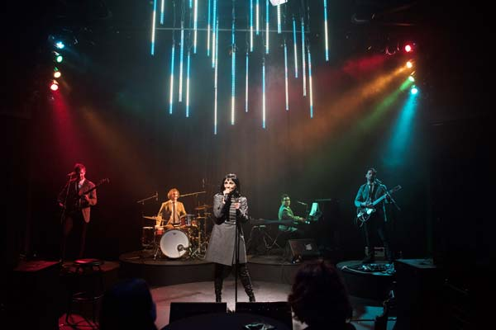
Image © Dylan Evans
In the end, all the elements of an electrifying stage show were there but it truly was the music that took centre stage and rightly so. Price and her team paid homage to the immense impact that The Beatles had on so many people around the world with beautiful arrangements and a fabulous medley at the end to ensure everyone’s favourite Beatles tunes made an appearance.
If you didn’t leave feeling a myriad of messy beautiful emotions, it can probably be safely said that you’re a robot.
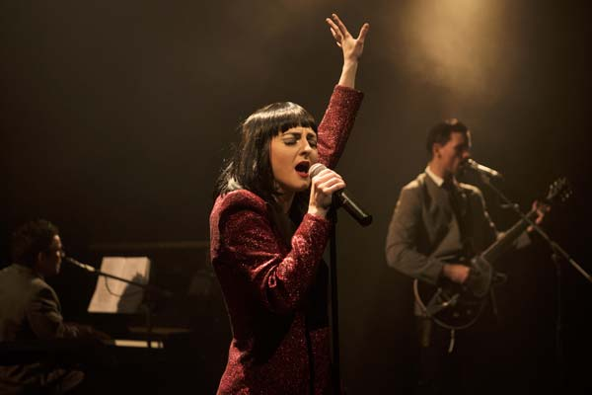
Image © Dylan Evans

